Healthcare Content Generator

Manufacturing Operational Insights Report

  - Course Name : Generative AI

Institution Name: Medicaps University – Datagami Skill Based Course

Student Name(s) & Enrolment Number(s):
Sr no | Student Name | Enrolment Number
1. | PRAKHAR JAIN | EN24CA5030122
2. | AAYUSH | EN22IT301004
3. | DANISH SHAIKH | EN22IT301032
4. | KOMOLIKA VYAS | EN24CA5030083
5. | KASHISH BILALA | EN24CA5030079

Group Name: Group 04D12
Project Number: GAI-42
Industry Mentor Name: Rishabh
University Mentor Name: Ajaj Khan
Academic Year:2025-2026

Table of Contents
Page No.
1. Introduction 3
2. Problem Statement & Objectives 4-9
2.1 Problem Statement 4-5
2.2 Project Objectives 6-7
2.3 Scope of the Project 8-9
3. Proposed Solution 10-18
3.1 Key features 10-12
3.2 Overall Architecture / Workflow 13-16
3.3 Tools & Technologies Used 17-18
4. Results & Output 19-31
4.1 Screenshots / outputs 19-25
4.2 Reports / dashboards / models 26-29
4.3 Key outcomes 30-31
5.Conclusion 32-33
6.Future Scope & Enhancements 34-35

1. Introduction
The rapid growth of digital healthcare platforms has created an increasing demand for reliable, scalable, and easily understandable medical content. Patients today actively search for information related to diseases, symptoms, treatments, and preventive care through websites, mobile applications, and chatbots. However, creating high-quality healthcare content manually is a complex and time-consuming task that requires medical expertise, consistency, and continuous updates. In many cases, the available information online is either too technical for general users or lacks accuracy and personalization.
To address these challenges, the Healthcare Content Generator using Generative AI is proposed as an intelligent system that automates the creation of healthcare-related content. This system leverages the power of Generative Artificial Intelligence (Gen AI) to produce human-like, context-aware, and informative medical text. It is designed to assist healthcare providers, organizations, and digital platforms in delivering accurate and user-friendly content at scale.
Generative AI, particularly Large Language Models (LLMs), has revolutionized the way machines understand and generate natural language. These models are trained on vast amounts of textual data and can generate coherent and contextually relevant responses based on user input. In the context of healthcare, LLMs can be used to generate explanations of medical conditions, suggest preventive measures, and provide general health guidance in a simplified manner. However, relying solely on pre-trained models may sometimes result in outdated or generic responses.
To enhance accuracy and relevance, the system integrates a Vector Database, which plays a crucial role in storing and retrieving domain-specific healthcare information. Medical documents, articles, and guidelines are converted into numerical representations known as embeddings and stored in the vector database. When a user submits a query, the system performs a semantic search to find the most relevant information based on meaning rather than just keywords. This ensures that the generated content is grounded in reliable data and tailored to the user’s query.
The entire system is implemented using Python, which serves as the backbone for integrating various components such as the user interface, API communication, data processing, and model interaction. Python’s extensive libraries and frameworks make it an ideal choice for building scalable and efficient AI-powered applications.
The working of the Healthcare Content Generator involves multiple stages. First, the user provides a healthcare-related query, such as information about a disease or its symptoms. This input is processed and converted into embeddings, which are then used to search the vector database for relevant medical content. The retrieved information is passed to the LLM through an API, which generates a well-structured and easy-to-understand response. The final output is then delivered to the user in natural language form.
This system offers several advantages. It significantly reduces the time and effort required for content creation, ensures consistency in information delivery, and enables scalability for large healthcare platforms. Additionally, it can be integrated into chatbots, telemedicine applications, hospital websites, and health advisory systems to provide instant and reliable information to users.
Despite its benefits, the system also has certain limitations. Since it relies on AI-generated content, there is a possibility of inaccuracies if the underlying data is not properly curated. Therefore, it is important to use validated medical sources and, in critical scenarios, involve human experts for verification. Future improvements can include real-time data integration, multilingual support, voice-based interaction, and personalized healthcare recommendations.

2. Problem Statement & Objectives

2.1 Problem Statement
The healthcare industry is experiencing rapid digital transformation, with an increasing reliance on online platforms such as hospital websites, telemedicine applications, and health advisory chatbots. Patients and users frequently seek medical information online regarding symptoms, diseases, treatments, and preventive care. However, the availability of accurate, reliable, and easy-to-understand healthcare content remains a significant challenge.
One of the primary problems is that most medical content available on the internet is either too complex for the general public or not sufficiently personalized to individual user needs. Medical literature is often written in technical language that is difficult for non-medical users to understand, leading to confusion, misinformation, and sometimes incorrect self-diagnosis. On the other hand, simplified content may lack depth, accuracy, or credibility.
Another major issue is the manual effort required to create and maintain healthcare content. Content creation in the medical domain requires domain expertise, time, and continuous updates to reflect the latest medical guidelines and research. Healthcare organizations must invest significant resources in content writing, review, and publishing, which is not always scalable or cost-effective. As a result, many platforms struggle to keep their information updated and consistent.
Additionally, there is a lack of real-time, context-aware responses in traditional healthcare information systems. Most systems rely on static content or keyword-based search, which fails to understand the intent behind user queries. This often leads to irrelevant or generic results, reducing the overall user experience and trust in the platform.
The problem is further complicated by the growing demand for personalized healthcare information. Users expect responses tailored to their specific queries, conditions, or symptoms. Traditional systems are not capable of dynamically generating such personalized content, which creates a gap between user expectations and system capabilities.
Moreover, the risk of misinformation and inconsistency in healthcare content is a critical concern. Incorrect or outdated medical information can have serious consequences for users. Therefore, any automated system must ensure that the generated content is accurate, relevant, and based on reliable sources.
To address these challenges, there is a need for an intelligent system that can:
- Automatically generate accurate and easy-to-understand healthcare content
- Reduce the dependency on manual content creation
- Provide context-aware and personalized responses
- Ensure scalability and consistency across platforms
- Retrieve and utilize reliable medical knowledge effectively
The proposed solution, a Healthcare Content Generator using Generative AI, aims to solve these problems by leveraging advanced technologies such as Large Language Models (LLMs), vector databases, and semantic search. This system can understand user queries, retrieve relevant medical information, and generate high-quality content dynamically.
In summary, the core problem lies in the lack of efficient, scalable, and intelligent systems for generating reliable healthcare content that is both accurate and user-friendly. Addressing this problem is essential to improve access to healthcare information, enhance user experience, and support the growing needs of digital healthcare platforms.

2.2 Project Objectives

- To develop an automated healthcare content generation system
The primary objective is to design and build a system that can automatically generate healthcare-related content such as disease descriptions, symptoms, causes, prevention methods, and treatment options without manual intervention.

- To provide accurate and reliable medical information
The system aims to generate content that is factually correct and based on trusted medical data sources, reducing the risk of misinformation and improving user trust.
- To simplify complex medical information for general users
Another objective is to convert technical and complex medical terminology into simple, easy-to-understand language so that non-medical users can easily comprehend the information.
- To implement context-aware content generation
The system should understand the meaning and intent of user queries and generate responses that are relevant and specific, rather than generic or keyword-based outputs.
- To integrate Large Language Models (LLMs) for natural language generation
The project focuses on utilizing LLM APIs to produce human-like, coherent, and well-structured healthcare content dynamically.
- To utilize a Vector Database for efficient information retrieval
An important objective is to store healthcare data as embeddings in a vector database and enable semantic search to retrieve the most relevant information based on user queries.
- To ensure scalability of the system
The system should be capable of handling a large number of user requests simultaneously, making it suitable for deployment in large healthcare platforms and applications.
- To reduce manual effort and cost in content creation
By automating content generation, the project aims to minimize the need for manual writing, editing, and updating of healthcare content, saving time and resources.
- To enable personalized healthcare responses
The system should be able to generate content tailored to individual user queries, providing more relevant and customized information.
- To design a modular and flexible architecture
The project aims to build a system where components like the LLM, database, and API can be easily modified, upgraded, or replaced without affecting the entire system.

- To ensure consistency in generated content
The system should maintain a uniform tone, structure, and quality across all generated healthcare content.
- To support integration with various platforms
The solution should be easily integrable with chatbots, mobile applications, websites, and telemedicine platforms for wider usability.
- To improve user experience in accessing healthcare information
The system aims to provide quick, relevant, and easy-to-read responses, enhancing the overall experience for users seeking medical information.
- To enable real-time response generation
The objective is to ensure that the system can generate healthcare content instantly based on user queries, without delays.
- To maintain ethical and responsible AI usage
The system should be designed to provide general healthcare information responsibly, avoiding harmful or misleading suggestions and encouraging users to consult professionals when necessary.
- To allow future enhancements and extensibility
The project should support future upgrades such as multilingual capabilities, voice-based interaction, and integration with real-time medical data sources.

2.3 Scope of the Project

1. Content Generation Scope
The system is capable of generating a wide variety of healthcare-related content, including:
- Disease descriptions and overviews
- Symptoms and causes of medical conditions
- Preventive healthcare measures
- Basic treatment and care guidelines
- Lifestyle and wellness tips
The generated content is designed to be clear, structured, and user-friendly, making it suitable for both general users and healthcare platforms.

2. User Interaction Scope
The project supports interaction through:
- Text-based queries entered by users
- Chatbot-style interfaces for real-time communication
- Question-answer format for quick information access
Users can ask healthcare-related questions, and the system will generate instant, relevant, and context-aware responses.

3. Integration Scope
The system can be integrated into multiple platforms, such as:
- Healthcare websites
- Mobile applications
- Telemedicine platforms
- AI-powered chatbots
- Hospital management systems
This flexibility allows the solution to be used in both small-scale and enterprise-level healthcare environments.

4. Technology Scope
The project involves the use of advanced technologies, including:
- Python for backend development and system integration
- LLM APIs for natural language understanding and generation
- Vector Databases (like FAISS, Pinecone) for semantic search and data retrieval
This ensures that the system remains modern, efficient, and adaptable to future technological advancements.

5. Personalization Scope
The system has the capability to:
- Understand user intent and query context
- Generate customized responses based on input
- Provide tailored healthcare information
Although basic personalization is included, the scope can be extended to deeper personalization using user data in future versions.

6. Scalability Scope
The project is designed to handle:
- Multiple users simultaneously
- Large volumes of healthcare data
- Continuous expansion of content database
This makes the system suitable for large-scale deployment across healthcare platforms with high user traffic.

7. Data Handling Scope
The system can:
- Store and manage healthcare-related documents
- Convert text into embeddings for semantic search
- Retrieve relevant information efficiently
However, it primarily focuses on structured and semi-structured healthcare data and may require improvements for handling highly complex medical datasets.

8. Real-Time Response Scope
The system provides:
- Instant content generation
- Quick response to user queries
- Real-time interaction capabilities
This improves user experience and makes the system suitable for live applications like chatbots and virtual assistants.

9. Limitations within Scope
While the system offers many capabilities, its scope is limited to:
- Providing general healthcare information only
- Not replacing professional medical advice
- Dependence on the quality of training data and stored information
Critical medical decisions should still involve healthcare professionals.

10. Future Scope and Enhancements
The project has strong potential for future expansion, including:
- Multilingual support for wider accessibility
- Voice-based interaction using speech recognition
- Integration with real-time medical databases and APIs
- AI-based diagnosis support systems (with proper validation)
- Personalized health recommendations using user history
- Integration with wearable devices and health monitoring systems

3. Proposed Solution

3.1 Key features
1. Automated Healthcare Content Generation
The system is capable of automatically generating healthcare-related content without requiring manual writing. It can produce information on diseases, symptoms, causes, treatments, and preventive measures. This automation significantly reduces the workload of healthcare professionals and content creators while ensuring faster content availability.

2. Context-Aware and Intelligent Responses
The system understands the intent and context of user queries rather than relying only on keywords. By using semantic search and advanced AI models, it generates responses that are highly relevant and tailored to the specific query, improving the overall accuracy and usefulness of the information.

3. Integration of Retrieval-Augmented Generation (RAG)
The solution combines information retrieval (from a vector database) with content generation (using LLMs). This ensures that the generated responses are not only fluent but also grounded in reliable medical data, reducing the chances of incorrect or generic outputs.

4. Use of Vector Database for Semantic Search
The system stores healthcare data as embeddings in a vector database, enabling meaning-based search instead of simple keyword matching. This allows the system to retrieve the most relevant information even when the user query is phrased differently, improving the quality of results.

5. Human-Like Natural Language Generation
Using Large Language Models, the system generates responses in natural, human-like language. The content is well-structured, grammatically correct, and easy to read, making it accessible to users with different levels of medical knowledge.

6. Simplification of Complex Medical Information
Medical terminology can be difficult for general users to understand. The system translates complex medical concepts into simple and clear explanations, ensuring that users can easily comprehend the information without requiring a medical background.

7. Real-Time Response Generation
The system is designed to provide instant responses to user queries. This real-time capability makes it suitable for applications like healthcare chatbots, virtual assistants, and telemedicine platforms where quick information is essential.

8. Scalability and High Performance
The architecture of the system supports handling a large number of users and queries simultaneously. It can scale efficiently for use in large healthcare platforms, ensuring consistent performance even under heavy load.

9. Modular and Flexible Architecture
The system is built using a modular design, where components such as the LLM, vector database, and backend can be easily updated or replaced. This flexibility allows for future upgrades and integration of new technologies without major system changes.

10. Personalization Capability
The system can generate customized responses based on user queries and context. It can be further enhanced to include user-specific data, enabling personalized healthcare recommendations and improved user engagement.

11. Multi-Platform Integration
The solution can be integrated with various platforms, including:
- Websites
- Mobile applications
- Chatbots
- Telemedicine systems
This makes the system versatile and widely applicable across the healthcare ecosystem.

12. Consistency and Standardization
Unlike manual content creation, the system ensures that all generated content follows a consistent format, tone, and structure. This improves the quality and reliability of healthcare information across different platforms.

13. Efficient Data Handling and Retrieval
The system efficiently manages large volumes of healthcare data by converting it into embeddings and storing it in a vector database. This allows quick retrieval of relevant information, reducing response time and improving system efficiency.

14. Cost and Time Efficiency
By automating content generation, the system reduces the need for human intervention, saving both time and operational costs. It allows healthcare organizations to focus on more critical tasks.

15. Safe and Responsible AI Usage
The system is designed to follow ethical guidelines by:
- Providing general healthcare information only
- Avoiding harmful or misleading suggestions
- Including disclaimers where necessary
- Encouraging users to consult medical professionals

16. Support for Future Enhancements
The system is designed to support future improvements such as:
- Multilingual content generation
- Voice-based interaction
- Integration with real-time healthcare data
- Advanced personalization features

17. Improved User Experience
With fast, accurate, and easy-to-understand responses, the system enhances the overall user experience. It helps users quickly find the information they need, increasing satisfaction and engagement.

18. Continuous Learning and Improvement
The system can be updated with new data and improved models over time, allowing it to stay up-to-date with the latest medical knowledge and trends.

3.2 Overall Architecture / Workflow

1. User Interface Layer
- Web App (React / HTML-CSS / Streamlit)
- User inputs:
  - Topic (e.g., diabetes, fitness)
  - Content type (blog, report, social post)
  - Target audience (patients, doctors, general public)
2. Backend (Python API Layer)
- Built using:
  - FastAPI / Flask
- Responsibilities:
  - Receive user input
  - Validate request
  - Orchestrate GenAI pipeline
  - Call LLM API
  - Fetch context from Vector DB

3. Data Ingestion Pipeline
- Collect healthcare data from:
  - Medical articles
  - Research papers
  - Guidelines (WHO, etc.)
- Steps:
  - Data cleaning
  - Text chunking
  - Convert into embeddings (using models like OpenAI embeddings)
4. Vector Database (Knowledge Base)
- Examples:
  - Pinecone
  - FAISS
  - Weaviate
- Stores:
  - Text embeddings
  - Metadata (topic, source, category)
5. Retrieval Layer (RAG - Retrieval Augmented Generation)
- When user sends a query:
  - Convert query → embedding
  - Search Vector DB
  - Retrieve top relevant chunks
6. LLM API Layer
- Examples:
  - OpenAI GPT API
  - Claude / Gemini
- Input:
  - User query
  - Retrieved context
  - Prompt template
- Output:
  - High-quality healthcare content

7. Prompt Engineering Layer
- Custom templates like:
  - "Generate a medically accurate blog..."
  - "Explain in simple terms..."
- Ensures:
  - Accuracy
  - Tone control
  - Audience targeting

8. Post-Processing Layer
- Tasks:
  - Grammar correction
  - Fact-checking (optional)
  - Formatting (headings, bullets)

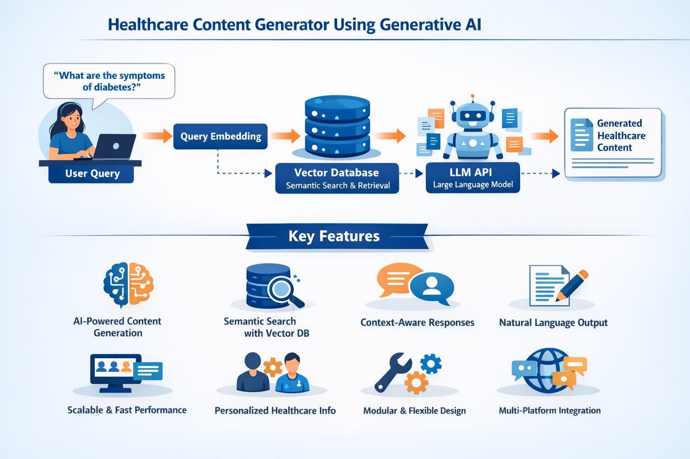

Step-by-step Workflow
Step 1: User Query Input
- The process starts when a user enters a healthcare-related query
- Example: “What are the symptoms of diabetes?”
- Input can be from:
  - Website
  - Mobile app
  - Chatbot

Step 2: Query Preprocessing
- The system cleans and processes the input:
  - Removes unnecessary words
  - Normalizes text (lowercase, etc.)
- Prepares the query for further processing

Step 3: Convert Query into Embeddings
- The processed query is converted into numerical vectors (embeddings)
- This helps the system understand the meaning of the query, not just keywords

Step 4: Semantic Search in Vector Database
- The query embedding is sent to the Vector Database
- The database:
  - Compares it with stored embeddings
  - Finds the most relevant healthcare documents
- This is called semantic search (meaning-based search)

Step 5: Retrieve Relevant Data
- The system retrieves:
  - Medical articles
  - Healthcare guidelines
  - Stored knowledge
- Only the most relevant information is selected

Step 6: Context Preparation
- Retrieved data is:
  - Filtered
  - Organized
  - Converted into structured context
- This context is passed to the AI model

Step 7: Input to LLM (Generative AI Model)
- The system sends:
  - User query
  - Retrieved context
- To the LLM API (Large Language Model)

Step 8: Content Generation
- The LLM:
  - Understands the input
  - Generates human-like healthcare content
- Output includes:
  - Explanation
  - Symptoms
  - Causes
  - Prevention tips

Step 9: Post-Processing of Output
- The generated content is:
  - Cleaned
  - Formatted
  - Structured (headings, points, etc.)

Step 10: Response Delivery to User
- Final output is displayed to the user
- Delivered via:
  - Chat interface
  - Website
  - App

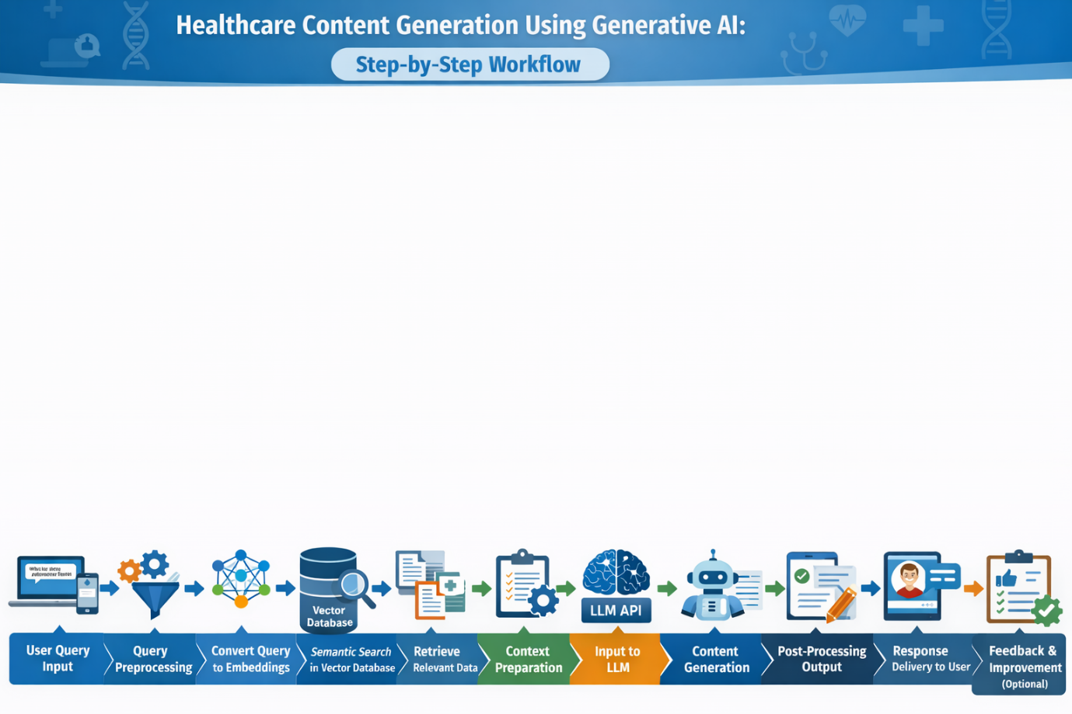

3.3 Tools & Technologies Used

1. Programming Language: Python
Python is the core technology used to build the system.
Purpose:
- Backend development
- API integration
- Data processing
- Handling workflows

2. Generative AI Model (LLM API)
Large Language Models (LLMs) are used to generate healthcare content.
Examples:
- OpenAI GPT APIs
- Other LLM providers

3. Vector Database
Used to store and retrieve data using embeddings.
Examples:
- FAISS
- Pinecone
- Chroma
Purpose:
- Store medical documents as vectors
- Perform semantic (meaning-based) search
- Retrieve relevant information quickly

4. Embedding Models
These models convert text into numerical vectors.
Examples:
- OpenAI Embeddings
- Sentence Transformers

5. Backend Frameworks (Optional but Recommended)
Used to build APIs and handle server-side logic.
Examples:
- FastAPI
- Flask

6. Frontend Technologies
Used to create user interface.
Examples:
- HTML, CSS, JavaScript
- React (for advanced UI)
7. Database (Optional)
Used to store user data and logs.
Examples:
- MySQL
- MongoDB

8. API Integration Tools
Used to connect different services.
Examples:
- REST APIs
- Postman (for testing)

9. Deployment Platforms
Used to host and run the application.
Examples:
- AWS
- Render
- Vercel
- Heroku

10. Version Control System
Used to manage code changes.
Examples:
- Git
- GitHub

11. Libraries and Frameworks
Some important Python libraries:
- NumPy / Pandas → Data handling
- LangChain → LLM workflow management
- Transformers → NLP models
- Scikit-learn → Basic ML utilities
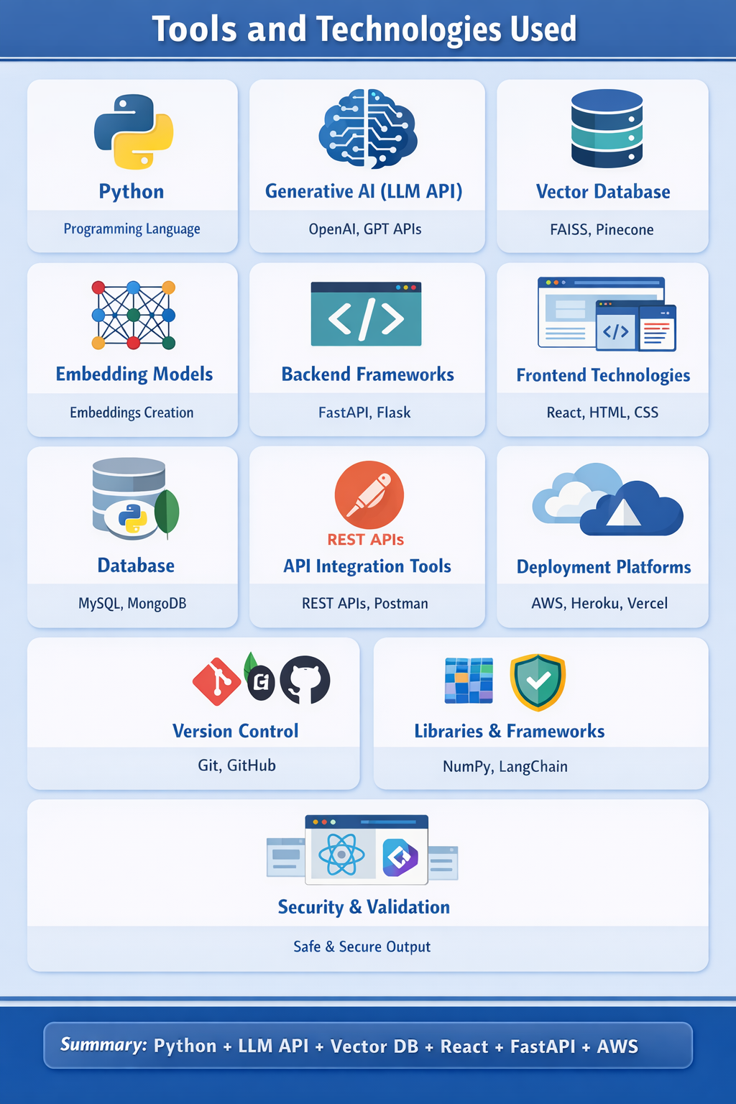
4. Results & Output

4.1 Screenshots / outputs
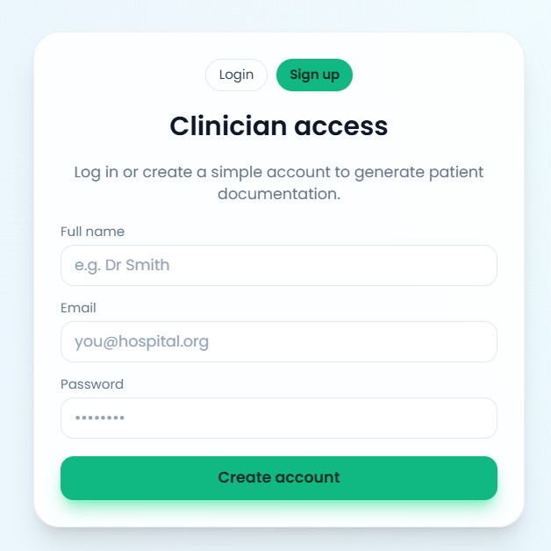

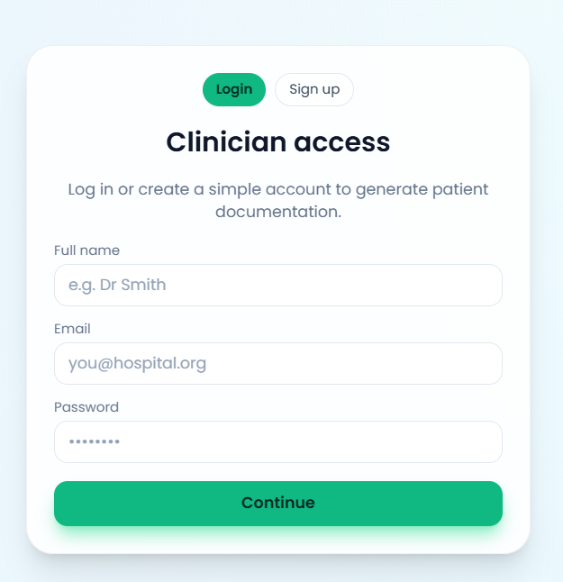

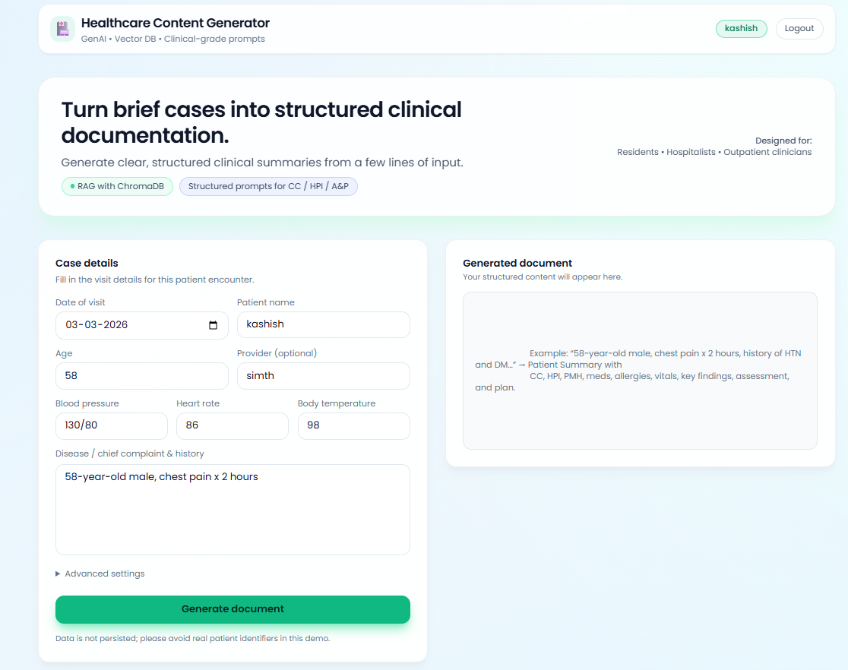

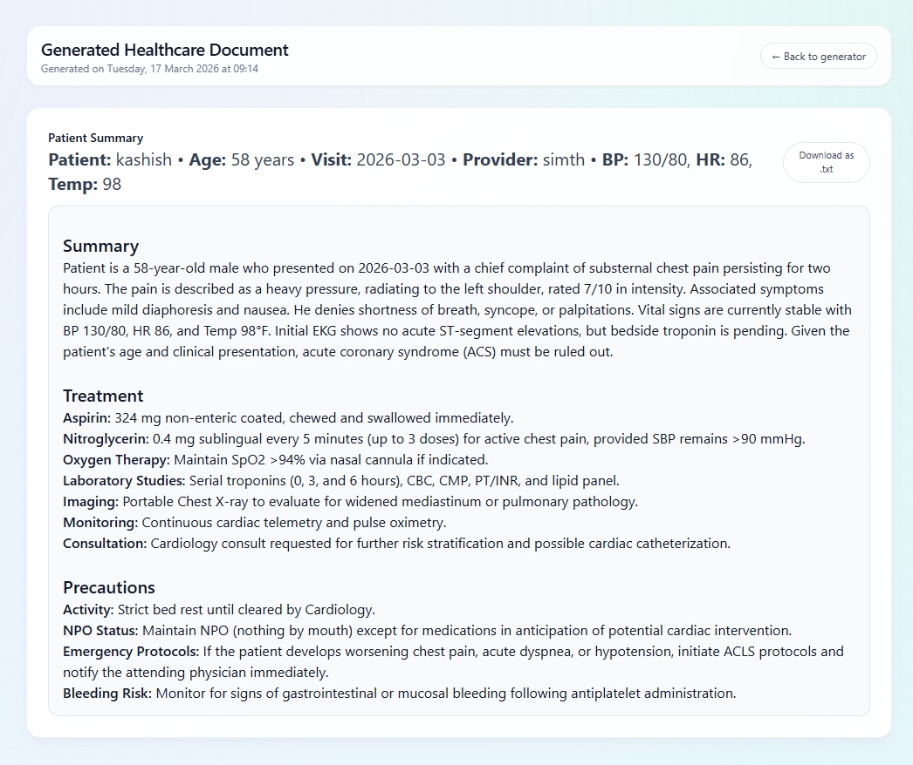

4.3 Key outcomes

1. Automated Healthcare Content Creation
The project successfully delivers a system that can automatically generate healthcare-related content such as symptoms, causes, treatments, and preventive measures. This reduces dependency on manual content writing and speeds up information delivery.

2. Improved Accessibility to Healthcare Information
The system makes medical information more accessible by providing simple, easy-to-understand explanations. Users without a medical background can easily understand complex health topics.

3. Context-Aware and Relevant Responses
The system generates responses based on the user’s query intent, ensuring that the information provided is relevant and specific rather than generic or unrelated.

4. Integration of AI with Healthcare Domain
The project demonstrates the successful integration of Generative AI technologies (LLMs) with healthcare data, showcasing how AI can be used in real-world applications for content generation.

5. Efficient Use of Vector Database for Semantic Search
The implementation of a vector database enables semantic search, allowing the system to retrieve the most relevant medical information based on meaning rather than keywords.

6. Real-Time Response Generation
The system provides instant responses to user queries, improving user experience and making it suitable for applications like chatbots and virtual assistants.

7. Scalable and Flexible System Design
The project results in a system that can handle multiple users and large datasets, making it scalable for deployment in real-world healthcare platforms.

8. Reduction in Time and Cost
By automating content generation, the project significantly reduces the time, effort, and cost required for manual healthcare content creation and maintenance.

9. Consistent and Standardized Content
The system ensures that all generated content follows a consistent structure and tone, improving reliability and quality across different outputs.

10. Foundation for Advanced Healthcare Applications
The project provides a strong base for future developments such as:
- AI-powered healthcare chatbots
- Personalized health recommendation systems
- Integration with telemedicine platforms

11. Enhanced User Experience
Users receive quick, accurate, and well-structured responses, leading to better engagement and satisfaction.

12. Demonstration of Modern AI Architecture (RAG)
The project successfully implements a Retrieval-Augmented Generation (RAG) approach, combining retrieval and generation for better performance and accuracy.

13. Support for Future Enhancements
The system is designed in a way that allows future upgrades like:
- Multilingual support
- Voice-based interaction
- Integration with real-time medical APIs

14. Responsible AI Usage Awareness
The project highlights the importance of:
- Using trusted data
- Avoiding misinformation
- Encouraging professional medical consultation

5. Conclusion
The Healthcare Content Generator using Generative AI successfully demonstrates how modern AI technologies can be leveraged to address the growing demand for accurate, scalable, and user-friendly healthcare information. By integrating Large Language Models (LLMs) with vector databases and a Python-based backend, the system provides an efficient solution for generating high-quality medical content dynamically.
The project effectively overcomes the limitations of traditional healthcare content systems, which rely heavily on manual effort and static information. Through the use of Retrieval-Augmented Generation (RAG), the system ensures that the generated responses are not only fluent and natural but also grounded in relevant and reliable data. This significantly improves the accuracy, relevance, and usefulness of the content provided to users.
One of the key achievements of this project is its ability to simplify complex medical information into easy-to-understand language, making healthcare knowledge more accessible to the general public. Additionally, the system provides real-time, context-aware responses, enhancing user experience and enabling its application in chatbots, telemedicine platforms, and healthcare websites.
The project also highlights important aspects such as scalability, flexibility, and cost efficiency, making it suitable for deployment in large-scale healthcare environments. At the same time, it emphasizes the need for responsible AI usage, ensuring that the system provides general guidance while encouraging users to seek professional medical advice for critical situations.
Although the system has certain limitations, such as dependency on data quality and the need for validation of medical information, it lays a strong foundation for future advancements. With further improvements like multilingual support, personalization, and integration with real-time healthcare data, the system can evolve into a more advanced and intelligent healthcare assistant.
In conclusion, this project showcases the powerful potential of Generative AI in transforming the healthcare domain by improving access to information, reducing manual effort, and enhancing the overall quality of digital healthcare services.

6. Future Scope & Enhancements

1. Multilingual Support
The system can be enhanced to support multiple languages such as Hindi, English, and other regional languages. This will make healthcare information accessible to a wider audience, especially in diverse countries like India where users prefer content in their native language.

2. Voice-Based Interaction
Future versions of the system can include speech recognition and text-to-speech capabilities, allowing users to interact using voice commands. This will improve accessibility for elderly users and those with limited literacy.

3. Personalized Healthcare Recommendations
The system can be upgraded to provide personalized health suggestions based on user data such as age, gender, medical history, and lifestyle. This will make the responses more relevant and useful.

4. Integration with Real-Time Medical Databases
The project can be extended by integrating with live medical databases and APIs to provide up-to-date information about diseases, treatments, and medical research.

5. AI-Based Symptom Checker
A future enhancement can include a symptom checker module, where users input symptoms and the system suggests possible conditions along with recommendations. This feature should be implemented carefully with proper disclaimers.

6. Mobile Application Development
The system can be converted into a dedicated mobile application for Android and iOS platforms, increasing accessibility and user engagement.

7. Integration with Wearable Devices
Future scope includes connecting the system with wearable health devices (like fitness bands or smartwatches) to monitor real-time health data and provide insights or alerts.

8. Advanced Data Security and Privacy
Healthcare data is sensitive, so future improvements can focus on:
- Data encryption
- Secure authentication
- Compliance with healthcare data regulations

9. Improved Accuracy with Domain-Specific Models
The system can be enhanced by using fine-tuned or domain-specific medical AI models, which will improve the accuracy and reliability of generated content.

10. Chatbot and Virtual Assistant Integration
The system can be expanded into a fully functional AI healthcare assistant integrated with:
- Hospital websites
- Customer support systems
- Telemedicine platforms

11. Image and Report Analysis
Future versions can include the ability to:
- Analyze medical reports
- Interpret images like X-rays (with AI models)
- Provide insights based on uploaded files

12. Continuous Learning and Feedback System
The system can improve over time by:
- Collecting user feedback
- Updating database content
- Learning from new data

13. Offline Mode Support
A lightweight version of the system can be developed to work offline or in low-internet areas, improving accessibility in rural regions.

14. Integration with Appointment and Hospital Systems
The system can be extended to:
- Book doctor appointments
- Suggest nearby hospitals
- Provide emergency contact information

15. Ethical AI and Validation Layer
Future improvements can include:
- A validation layer to verify generated content
- Stronger disclaimers
- Monitoring to prevent misinformation

